**Assignment Title**: Sales Distribution Dashboard of American Mall



**Submitted To**: Mr Mufthi Thanzeel  
**Submitted By**: Sandesh Devkota  
**Student ID**: 1193790

**Course Name and Code**: Data Visualization & ICT702

**Due Date**: Sep 25, 2025

Contents

**1.** **INTRODUCTION** 1

**1.1** **Background of the Case Study** 1

**1.2** **Purpose and Objectives of the Dashboard** 1

**1.3** **Target Audience and Decision-Making Needs** 1

**2.** **DATA PREPARATION AND METHODOLOGY** 2

**2.1** **Data Cleaning and Transformation** 2

**2.2** **Creation of Data Hierarchies** 2

**2.3** **Development of Pivot Tables** 3

**3.** **DASHBOARD DESIGN AND CONSTRUCTION** 4

**3.1** **Overview of Dashboard Layout** 4

**3.2** **Key Performance Indicators (KPIs)** 5

**3.3** **Visualizations Developed** 5

**4.** **APPLICATION OF DATA VISUALIZATION THEORIES AND PRINCIPLES** 8

**4.1** **Use of Color, Layout, and Chart Selection** 8

**4.2** **Ensuring Clarity and Reducing Cognitive Load** 8

**4.3** **Supporting Comparisons and Trend Identification** 8

**4.4** **Dashboard Interactivity and Drill-Down Capabilities** 9

**5.** **INSIGHTS AND STRATEGIC IMPLICATIONS** 9

**5.1** **Sales Performance Trends** 9

**5.2** **Profitability Insights Across Categories and Years** 9

**5.3** **Customer Contribution Analysis** 9

**5.4** **Regional (State-Wise) Performance** 10

**5.5** **Recommendations for Decision Makers** 10

**6.** **CONCLUSION** 11

**6.1** **Summary of Dashboard Strengths** 11

**6.2** **Limitations and Future Improvements** 11

**7.** **REFERENCES** 12

**8.** **APPENDICES** 14

**8.1** **Screenshots of Dashboard** 14

**8.2** **Pivot Tables and Calculations** 14

**LIST OF FIGURES**

Figure 1: Raw dataset to Clean Dataset 2

Figure 2: Development of Pivot Tables 3

Figure 3: Global filters (Category, Month, Year) 4

Figure 4: Dashboard Layout of Sales and Profit 4

Figure 5: Sales by Category (Funnel Chart) 5

Figure 6: Sales by State (Map Chart) 6

Figure 7: Sales By Months 6

Figure 8: Top 5 Customers by Profit 7

Figure 9: Count of Customer of Every Year 7

Figure 10: Profit by Year and Category (Clustered Column Chart) 8

# **INTRODUCTION**

## **Background of the Case Study**

This is a project that will entail the creation of a profit and sales performance dashboard using Microsoft Excel. American mall and data set offered in this dataset provides transactional information including product categories and sales, profit, customers, states and timelines. This is aimed at converting this raw data into meaningful actionable insights to decision-makers. Interactive dashboards are multiple visualizations that were aggregated to provide a real-time view of important metrics and trends, which can be common in business analytics (Olowe et al., 2024).

## **Purpose and Objectives of the Dashboard**

The dashboard is meant to offer a centralized, interactive, and visual platform to the managers and other stakeholders to monitor key performance indicators (KPIs). The objectives include:

* Presenting a clear overview of sales and profitability.
* Identifying high-performing and underperforming categories and regions.
* Recognizing top customers by sales contribution.
* Monitoring performance trends throughout the months and years.

The dashboard assists in strategic decision-making by enabling users to compare categories, monitor the change over time, and measure the drivers of profitability (Olowe et al., 2024). It makes it possible to summarize large amounts of data in the way that results in meaningful summaries, which leads to faster decision-making and decreases the use of static reports. The dashboard is also visually oriented to allow non-technical users to make sense of complex data easily.

## **Target Audience and Decision-Making Needs**

The target group is the sales managers, regional heads and top managers. Their main requirement is to enhance performance management of the sales managers by emphasizing profit and sales figures in real-time to facilitate efficient decision-making (Velcu-Laitinen and Yigitbasioglu, 2012). Regional heads will have geographical understanding whereas the executives will have the big picture angle of sales and profit patterns. The flexibility of the dashboard also makes it useful in both the long-term strategic planning and the operation decision-making.

# **DATA PREPARATION AND METHODOLOGY**

## **Data Cleaning and Transformation**

The raw data needed to be cleaned to be accurate. It involved the process of deleting duplicates, treating missing values, standardization of dates, and supporting categorical consistency (Microsoft, 2023). An example is that, negative anomalies in profit values were checked and customer names were reviewed to avoid duplication of customer names because of inconsistency in spelling. This type of preprocessing ensured credible and reliable results.

Figure 1: Raw dataset to Clean Dataset

## **Creation of Data Hierarchies**

It was developed with a date hierarchy (Year - Month - Day), to enable drill-down of the analysis. This will allow users to study the higher-level annual data trends and the finer details of the daily trends (ExcelDemy, 2024). An example is that executives might desire the year-by-year growth whereas the sales managers might desire the growth in terms of monthly or daily sales peaks.

## **Development of Pivot Tables**

Pivot tables were built to summarize sales and profit based on categories, regions and customers. These tables were the foundation of the visualizations of the dashboard (Microsoft, 2023). Pivot functionality was provided, which allowed grouping by states, filtering categories, and calculation of totals dynamically, which ensures versatility.

Figure 2: Development of Pivot Tables

* 1. **Application of Global Filters**

Global filters (Category, Month, Year) were provided to make it more interactive. These filters can also be customized by users, which ensures that the dashboard can be customized to suit various analytical requirements (Mount, 2024). As an example, executives might be interested in the performance of a particular year, whereas a regional manager will be interested in the sales of their state.

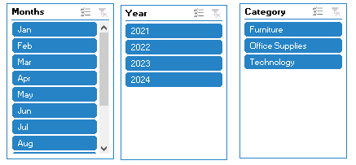

Figure 3: Global filters (Category, Month, Year)

# **DASHBOARD DESIGN AND CONSTRUCTION**

## **Overview of Dashboard Layout**

The dashboard has been made user-friendly with the KPIs on the top and detailed visualizations below. Such a design will allow managers to view all performance and then pass to the detailed analysis (Kobi, n.d.). The placement of filters on the side makes them easy to access without distracting from the visuals.

Figure 4: Dashboard Layout of Sales and Profit

## **Key Performance Indicators (KPIs)**

* **Total Sales:** Shows the total revenue and gives a top-level gauge, with which to compare the performance.
* **Total Profit:** Indicates net profit, and this shows financial success in relation to sales volume.
* **Profit Percentage (%):** Highlights profitability relative to sales, offering deeper insight into efficiency.

Together, these KPIs form the backbone of the dashboard, offering instant awareness of performance.

## **Visualizations Developed**

1. **Sales by Category (Funnel Chart):** Shows sales distribution across categories, highlighting strongest and weakest performers.

Figure 5: Sales by Category (Funnel Chart)

1. **Sales by State (Map Chart):** Visualizes geographical performance, allowing regional benchmarking.

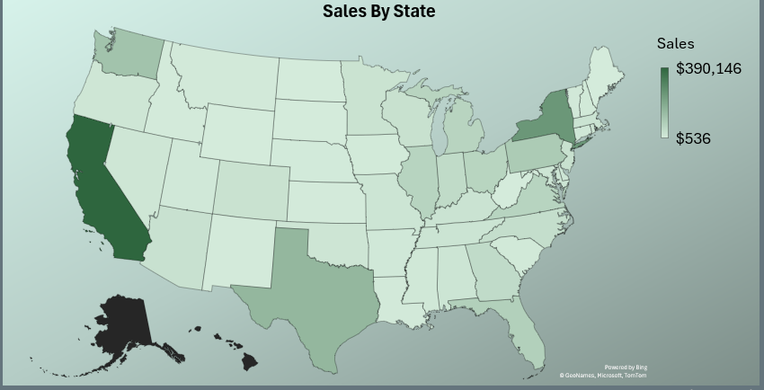

Figure 6: Sales by State (Map Chart)

1. **Sales by Month (Line Chart):** Identifies temporal trends and seasonal fluctuations.

Figure 7: Sales By Months

1. **Top 5 Customers (Bar Chart):** Highlights the most valuable customers by sales volume.

Figure 8: Top 5 Customers by Profit

1. **Customer Distribution (Donut Chart):** Represents proportional distribution of customer segments.

Figure 9: Count of Customer of Every Year

1. **Profit by Year and Category (Clustered Column Chart):** Compares profitability across categories over time

Figure 10: Profit by Year and Category (Clustered Column Chart)

# **APPLICATION OF DATA VISUALIZATION THEORIES AND PRINCIPLES**

## **Use of Color, Layout, and Chart Selection**

The categories were differentiated by consistent color schemes and remained readable. As an example, green color means profit, whereas sales are depicted in neutral colors (Zuga-Divre, 2016). The principles of visual hierarchy were implemented in such a manner that the most important KPIs are placed in bigger and more prominent boxes.

## **Ensuring Clarity and Reducing Cognitive Load**

Simple types of charts (bar, line and column) were used to eliminate unnecessary complexity. Data labels were also added where needed to enhance interpretability (CEIH, 2023). Information overload was avoided by eliminating redundant information.

## **Supporting Comparisons and Trend Identification**

Any category type to category comparisons can be made using comparative visuals like clustered columns, and the monthly and yearly trends can be identified with line charts (Optimize Smart, 2025). These assist managers to recognize the most successful categories and expect future peaks.

## **Dashboard Interactivity and Drill-Down Capabilities**

The global filters are used to increase interactivity. There is a possibility to drill down into categories, months, and years, which facilitates custom analysis (Microsoft, 2023). This will ensure that the same dashboard serves different users without the duplication of reports.

# **INSIGHTS AND STRATEGIC IMPLICATIONS**

## **Sales Performance Trends**

The line chart indicates that there were distinct seasonal peaks and especially the month of December where sales were rated at $241, 464 as compared to an average of $125, 000 in the other months. These spikes are very strong indicators of demand driven by the holidays, which provide a chance to plan inventory and organize promotion. On the other hand, the lowest sales were achieved in February ($97,000) and July ($102,000): it was necessary to focus on the off-season strategies to stabilize the revenues.

## **Profitability Insights Across Categories and Years**

The clustered column charts reflect the existence of a large variation in profitability between categories. Technology had made the most profit with its contribution of $121,862, then Office Supplies ($108,211) and Furniture (a low of $17,889). The furniture also showed a lack of consistency in the profitability of furniture across the years, which indicated that pricing structures, relevance of products, and costs of supply chain will need to be reviewed.

## **Customer Contribution Analysis**

The high concentration of revenue is pointed out at the customer-level analysis. The 5 customers who are the most profitable added about $30,100 of the total profit and the individual customer who will bring the biggest share of the profits is Tamara Chand with a total profit of $8,981. Although this shows the significance of key clients, it brings in a concentration risk. These relationships can be retained through the introduction of specific loyalty programs and cross-selling it would be better not to rely on a small amount of customers (Kotler et al., 2021).

## **Regional (State-Wise) Performance**

The map chart indicates a great difference in the performance of states. California had the highest sales of $390,146, then New York of $246,518 and Texas of $151,437. States like Alabama ($18,299) and Nevada ($19,100) on the other hand did much less than the national average. This data suggests that this demand is yet to be filled, and the marketing strategies in the region could use some enhancement, as well as distribution networks (Microsoft, 2023).

## **Recommendations for Decision Makers**

* Focus on the categories with high performance: Retain Technology and Office Supplies that generate more than 85 percent of the profits.
* Strength Furniture weakness: Conduct Profitability analysis of low-margin items in Furniture.
* Customer loyalty programs: Launch incentives with the best customers since the best 5 have almost 25 percent of overall profit.
* Seasonal campaigns: Target December due to the holiday campaign but also hold the off season sales in Feb/July to balance the streams of revenue.
* Geographic targeting: Increase distribution and marketing in the poorly performing states like Alabama and Nevada.

# **CONCLUSION**

## **Summary of Dashboard Strengths**

The dashboard is a rich and interactive summary of sales and profit that can be used to make informed decisions. Its design is clear and global filters are better to provide flexibility. It combines the strategic knowledge with usefulness in operations.

## **Limitations and Future Improvements**

* The current dashboard can only be limited to available historical data. Forecasting may be improved by predictive models.
* Combination with real time data sources would enhance responsiveness.
* The segmentation of customers (e.g., demographics) might be furthered to extract better insights
* The addition of mobile platforms would make it more accessible.

# **REFERENCES**

* CEIH. (2023). *Data visualisation style & best practice guide*. Central Eastern Integrated Health. <https://ceih.sa.gov.au/assets/library/document/CEIH-Data-Visualisation-Style-and-Best-Practice-Guide-2023.pdf>
* ExcelDemy. (2024, March 5). *Create date hierarchy in Excel Pivot Table* [Video]. YouTube. <https://www.youtube.com/watch?v=HxomcWCRuYw>
* Kobi, J. (n.d.). *(PDF) Developing dashboard analytics and visualization tools for effective performance management and continuous process improvement*. ResearchGate. <https://www.researchgate.net/publication/381186831_Developing_Dashboard_Analytics_and_Visualization_Tools_for_Effective_Performance_Management_and_Continuous_Process_Improvement>
* Kotler, P., Keller, K. L., Manceau, D., & Vigneron, F. (2021). *Marketing management* (16th ed.). Pearson. <https://www.pearson.com/en-us/pearsonplus/p/9780137344161>
* Microsoft. (n.d.). *Top ten ways to clean your data.* Microsoft Support. <https://support.microsoft.com/en-au/office/top-ten-ways-to-clean-your-data-2844b620-677c-47a7-ac3e-c2e157d1db19>
* Mount, G. (2024). *Modern data analytics in Excel*. Apress. <https://books.google.com/books?hl=en&lr=&id=zecEEQAAQBAJ&oi=fnd&pg=PP1>
* Olowe, K. J., Edoh, N. L., Zouo, S. J. C., & Olamijuwon, J. (2024). *Conceptual Review on the Importance of Data Visualization Tools for Effective Research Communication*. ResearchGate.<https://www.researchgate.net/publication/387033162_Conceptual_Review_on_the_Importance_of_Data_Visualization_Tools_for_Effective_Research_Communication>
* Optimize Smart. (2025, April 11). *Best types of Charts in Excel for data analysis, presentation and reporting*. <https://www.optimizesmart.com/how-to-select-best-excel-charts-for-your-data-analysis-reporting/>
* Velcu-Laitinen, O., & Yigitbasioglu, O. M. (2012). The Use of Dashboards in Performance Management: Evidence from Sales Managers. In *The International Journal of Digital Accounting Research* (Vol. 12, pp. 39–58). <https://doi.org/10.4192/1577-8517-v12_2>
* Zuga-Divre, L. (2016). *Creating a modern and responsive customer tracking dashboard* (Bachelor’s thesis). Laurea University of Applied Sciences. <https://www.theseus.fi/bitstream/handle/10024/119779/Zuga-Divre_Liliana.pdf>

# **APPENDICES**

## **Screenshots of Dashboard**

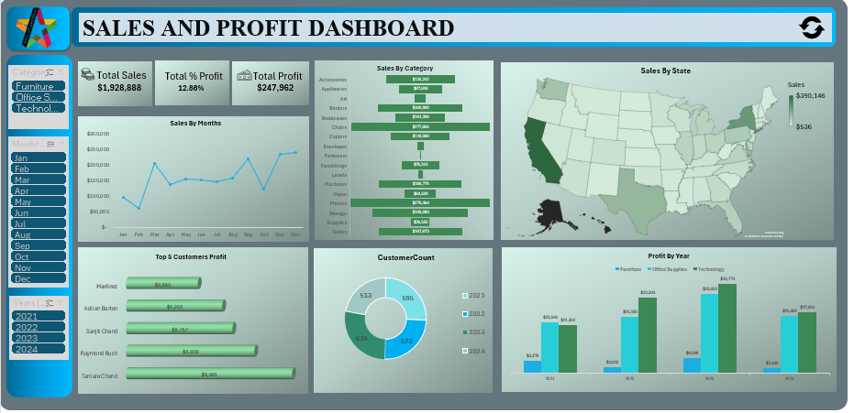

## **Pivot Tables and Calculations**

